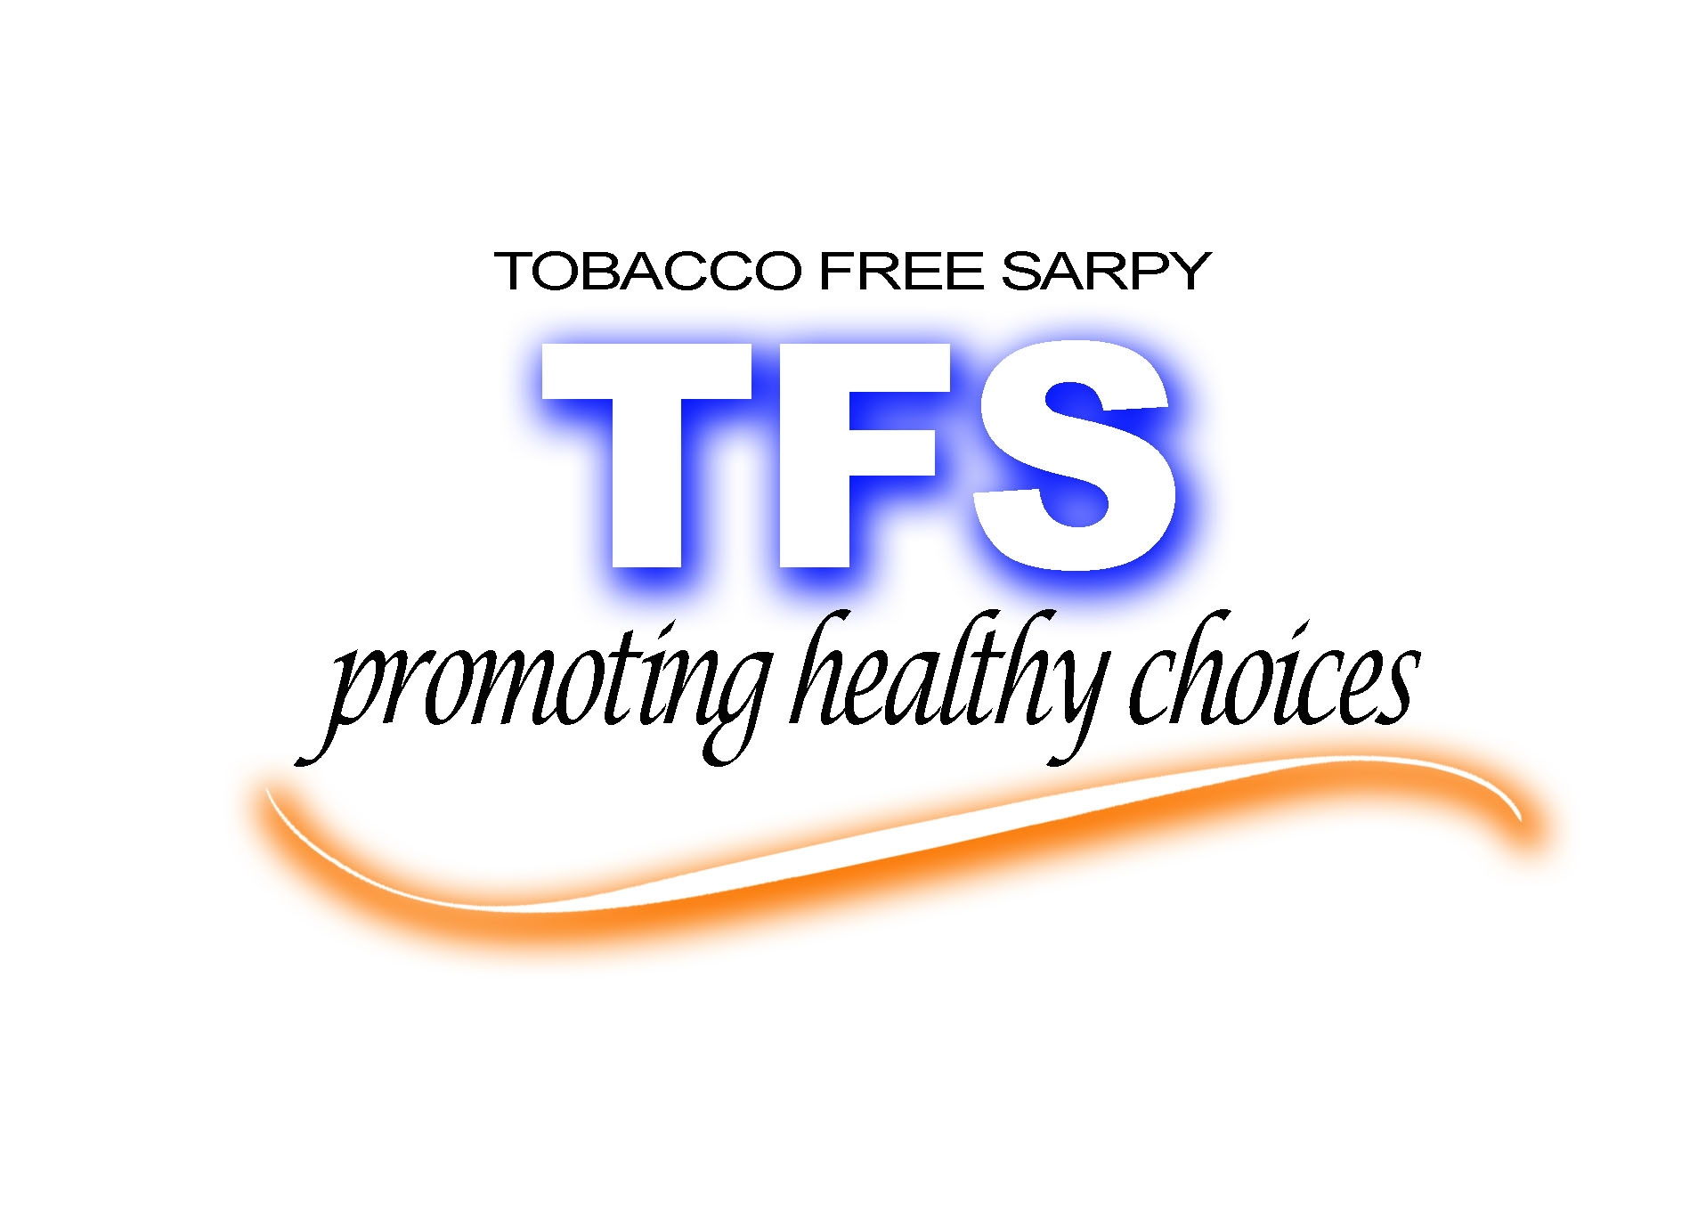
Tobacco Free Sarpy Recognition Luncheon
Alegent Health Midlands Hospital
April 15, 2010
Welcome and Networking
Lunch

Master of Ceremonies – Jeff Soukup
TFN/Department of Health and Human Services

Introductions
Tobacco Free Sarpy Accomplishments
Keynote Speaker – Senator Tim Gay
Award Presentations
TFS Coalition Partner of the Year
TFS Coalition Volunteer of the Year
TFS Coalition Law Enforcement Partner of the Year
Mayor Doug Kindig of La Vista – Presentation
TFS Coalition Sarpy Senator of the Year
Funding provided by the Nebraska Department of Health and Human Services/Tobacco Free Nebraska Program as a result of the Tobacco Master Settlement Agreement.
Tobacco Free Sarpy Recognition Luncheon
Alegent Health Midlands Hospital
April 15, 2010
Welcome and Networking
Lunch

Master of Ceremonies – Jeff Soukup
TFN/Department of Health and Human Services

Introductions
Tobacco Free Sarpy Accomplishments
Keynote Speaker – Senator Tim Gay
Award Presentations
TFS Coalition Partner of the Year
TFS Coalition Volunteer of the Year
TFS Coalition Law Enforcement Partner of the Year
Mayor Doug Kindig of La Vista – Presentation
TFS Coalition Sarpy Senator of the Year
Funding provided by the Nebraska Department of Health and Human Services/Tobacco Free Nebraska Program as a result of the Tobacco Master Settlement Agreement.

